**Refining User Stories**

The first step in refining a user story is to think about the amount of work involved in implementing the functionality. This will often depend on other downstream features that may or may not be already implemented. For instance, in the example given above, if the system already had in place most of the user sign-up capabilities (registering with username and password, changing password, remembering password, etc.), then this user story could be small enough in scope as it would involve adding perhaps the user session handling in the backend and a login button to the frontend. However, let's assume that we're starting from scratch. In this case, we will turn this user story into an epic.

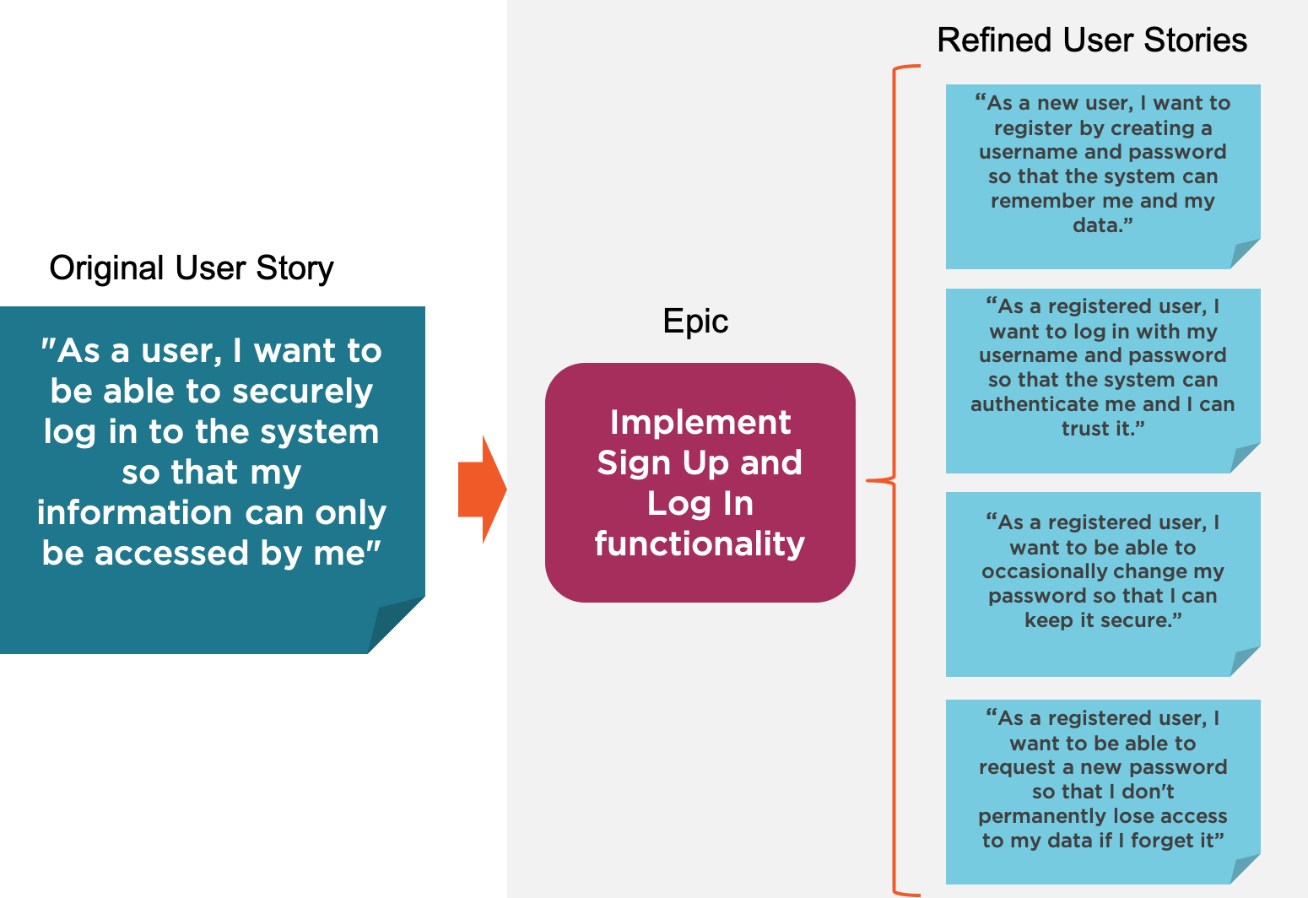

This epic will then include the following smaller user stories:

* As a new user, I want to register by creating a username and password so that the system can remember me and my data.
* As a registered user, I want to log in with my username and password so that the system can authenticate me and I can trust it.
* As a registered user, I want to be able to occasionally change my password so that I can keep it secure.
* As a registered user, I want to be able to request a new password so that I don't permanently lose access to my data if I forget it.

These smaller user stories are now more precise and refined in their scope and are more likely to fit each within a single sprint.

**Acceptance Criteria**

The acceptance criteria determine the specific conditions that the software product must satisfy to be accepted by and meet the expectations of the user. It also forms the basis for the acceptance testing stage.

During the refinement process, as larger user stories become epics and are broken down into smaller scoped user stories, it becomes easier to reason about the acceptance criteria and come up with a shortlist for each user story (less than five criteria listed, ideally one to three criteria as a good rule of thumb). If the list of acceptance criteria for any user story is too big, it may be an indication that the user story is too large in scope and should probably be split further.

Some guiding principles for defining acceptance criteria are:

* Each acceptance criterion should be independently testable
* Each acceptance criterion test should have a clear pass/fail result
* Acceptance criteria should be focused on the end result (functionality), not the mechanism through which it is achieved
* When relevant, "hidden" non-functional criteria should be included

An acceptance criterion is often expressed as a sentence following the structure:

"Given [precondition], when I [do some action] then I expect [result]”.

In the example above, the acceptance criteria for the first two stories could be:

| **User Story** | **Acceptance Criteria** |
| --- | --- |
| As a new user, I want to register by creating a username and password so that the system can remember me and my data. | Given that I am a new user, when I go to the sign up page and enter an username and password and click on sign up, then I am successfully registered and able to log in with my chosen credentials. |
| As a registered user, I want to log in with my username and password so that the system can authenticate me and I can trust it. | 1. Given that I am a registered user and logged out, if I go to the log in page and enter my username and password and click on Log in, then the data associated to my user should be accessible.  2. Given that I am a registered user and logged out, if I go to the log in page and enter my username but an incorrect password and click on Log in, then log in fails with an error message that specifies that the username or password was wrong. |

**Adding Non-functional Requirements**

As mentioned earlier, a good practice in defining acceptance criteria is to also include non-functional requirements, i.e., requirements related to the system's qualities and attributes that are not necessarily directly related to the functionality, but are crucial in meeting the user's expectations in regards to the system's behavior.

For example, building on the list of acceptance criteria for the user story:

"As a registered user, I want to log in with my username and password so that the system can authenticate me and I can trust it."

We can add as a criterion:

"Given that I am a registered user and logged out, if I go to the login page and enter my username and password and click on Log in, then my user login session is loaded in less than eight seconds."